Domain 2: Assessment, Evaluation, and Diagnosis

Total questions: 159

Testlets: 4

Multiple Choice Question
1. You are seeing a patient who has complaints of elbow pain and swelling. The patient works a desk job and spends a lot of time resting their elbows on the armrest of their desk chair. You believe this has caused the swelling seen on the elbow pictured. What is the most likely diagnosis for this patient?
Insert: 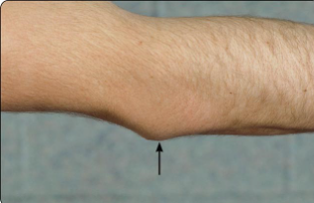
\P 05.02 ID701183\

a. Lateral epicondylitis
b. Cubital tunnel syndrome
*c. Olecranon bursitis
d. Fractured elbow
e. Volkmann’s ischemic contracture

2. What possible injury is indicated by an inability to pronate and supinate the forearm with point tenderness over the radial head?
a. Olecranon fracture
b. Little Leaguer’s elbow
c. Osteochondritis dissecans
d. Medial collateral ligament sprain
*e. Radial head fracture or dislocation

3. An athlete fell on an outstretched arm during practice and has dislocated their elbow. What is the most common direction of displacement in an elbow (humeroulnar joint) dislocation?
a. Medial
b. Lateral
c. Anterior
d. Superior
*e. Posterior

4. When doing the radioulnar joint stress test, which ligament is examined for pain and laxity?
*a. Annular ligament
b. Medial collateral ligament
c. Posterior ulnar collateral ligament
d. Lateral collateral ligament
e. Anterior ligament

5. What is the normal carrying angle of the elbow?
a. 0° to 5°
*b. 5° to 15°
c. 15° to 25°
d. 25° to 30°
e. >30°

6. A patient has noticed a gradual onset of pain at the medial aspect of the wrist. It is most notable during lifting or when grasping heavy items. Which special test is most likely to be positive?
a. Trigger finger test
*b. Finkelstein’s test
c. Bunnel-Littler test
d. Retinacular test
e. Extender tendon test

7. Which of the carpal bones is most commonly fractured?
a. Lunate
*b. Scaphoid
c. Trapezium
d. Triquetrum
e. Hamate

8. Which special test is pictured?
Insert: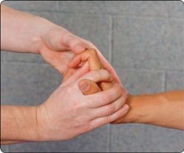
\P 05.03 ID701184\

a. Trigger finger test
b. Retinacular test
*c. Bunnel-Littler test
d. Compression test
e. Finkelstein’s test

9. Which nerve is involved in carpal tunnel syndrome?
a. Radial nerve
b. Ulnar nerve
c. Musculocutaneous nerve
d. Axillary nerve
*e. Median nerve

10. What is the percentage, on average, that someone is in the stance phase of the walking gait compared to the swing phase of gait?
a. 40% in stance, 60% in swing
b. 65% in stance, 35% in swing
c. 35% in stance, 65% in swing
*d. 60% in stance, 40% in swing
e. 50% in stance, 50% in swing

11. What instrument can the athletic trainer use to assess pulmonary function?
a. V̇O₂ max
*b. Peak flow meter
c. Portable ultrasound
d. Respirometer
e. Fluoroscope

12. How is asthma defined?
a. Blood accumulating in the pleural space
b. Coughing up blood
*
c. A reversible airway obstruction that results from hyperreactivity
d. Fluid accumulation in the thorax
e. A respiratory condition leading to a residual cardiac condition

13. What is the underlying physiological mechanism of sickle cell anemia?
a. An individual’s race
b. A decrease in circulating red blood cells
c. An iron deficiency in diet
d. A relative increase in blood plasma volume
*e. Abnormally shaped red blood cells

14. What valve is an athletic trainer listening to when performing cardiac auscultation within the right second intercostal space at the right sternal border?
a. Mitral
b. Pulmonary
*c. Aortic
d. Tricuspid
e. Cardiac

15. What valve is an athletic trainer listening to when performing cardiac auscultation within the fourth intercostal space along the lower left sternal border?
a. Aortic
*b. Tricuspid
c. Mitral
d. Pulmonary
e. Cardiac

16. Which of the following ear-related conditions does this image indicate?
Insert: 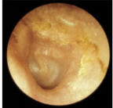
\P 05.04 ID 701185\
*a. Otitis externa
b. Otitis media
c. Cholesteatoma
d. Normal tympanic membrane
e. Auricular hematoma

17. What condition is shown in this figure?
Insert: 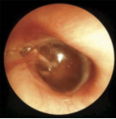
\P 05.05 ID 701186\
a. Otitis externa
b. Cholesteatoma
*c. Otitis media
d. Normal tympanic membrane
e. Auricular hematoma

18. What part of the eye is composed of a dense white connective tissue that makes up 90% of the outer layer of the eyeball globe?
a. Choriocapillaris
b. Iris
*c. Sclera
d. Macula
e. Retina

19. Three athletes present in the athletic training facility with complaints of diarrhea, vomiting, nausea, and abdominal cramping one to three hours after eating at a local restaurant. What may be the problem?
a. Bowel obstruction
b. Dysentery
c. Parasitic infection
*d. Food poisoning
e. Viral gastroenteritis

20. A patient presents to the athletic trainer in the early morning, before class, with an eye that looks like that in the photo. They complain that their eye is itchy and painful with “disgusting yellow discharge on the pillow.” They are also complaining of blurred vision. What condition could the patient have?
Insert: 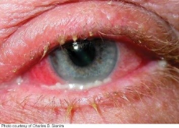
\P 05.06 ID 701187\
a. Corneal abrasion
b. Foreign body in the eye
c. Iritis
*d. Conjunctivitis
e. Stye

21. What is poliomyelitis?
a. An infection by a polio-parasitic infection that attacks motor neurons in the spinal cord
*b. An infection by the poliovirus that attacks motor neurons in the spinal cord
c. An infection by the polio bacterium that attacks motor neurons in the spinal cord
d. An infection by the polio bacterium that attacks sensory neurons in the spinal cord
e. An infection by the poliovirus that attacks sensory neurons in the spinal cord

22. Which of the following conditions is associated with disproportionate pain, extreme skin sensitivity, a burning sensation, and hyperhidrosis?
*a. Complex regional pain syndrome
b. Amyotrophic lateral sclerosis
c. Cerebral palsy
d. Multiple sclerosis
e. Muscular dystrophy

23. Which of the following consequences may occur after a prolonged bout of diarrhea (24 to 36 hours)?
a. Influenza
*b. Dehydration
c. Loss of appetite
d. Weight loss
e. Suppressed immune system

24. Which condition can lead to congenital defects or death to infants if the mother becomes infected within the first trimester?
a. Hepatitis
b
. Lyme disease
c. Streptococcal infections
d. Mumps
*e. Rubella

25. What is the underlying pathophysiology of type 2 non-insulin-dependent diabetes mellitus?
a. Inability to produce insulin
b. Increased insulin receptor sensitivity
*c. Inability to use insulin effectively
d. Increased insulin secretion
e. Inability to produce insulin receptor sites

26. Which definition below best describes sports hematuria?
a. An indication that something is wrong with the kidneys
*b. Benign self-limiting blood in the urine associated with activity and no associated trauma
c. A lack of a menstrual cycle due to excessive sport activity
d. Occult blood in the urine indicating potentially serious kidney damage associated with sports
e. Something found in a high percentage of marathon or long-distance runners

27. A patient complains to an athletic trainer of unplanned weight loss, polyuria, and polydipsia. The team physician suspects the patient may be diabetic and orders a blood test. What would confirm the physician’s suspicion this person is a diabetic?
a. <150 mg/dl
b. 100 mg/dl
c. A1C of 6.2
*d. >200 mg/dl
e. A1C of 5.4

28. Which of the following diseases is malignant?
a. Fibromyalgia
b. Lyme disease
c. Scleroderma
*d. Hodgkin’s lymphoma
e. Amyotrophic lateral sclerosis

29. Which term best describes the end-feel created when two muscles come in contact with each other?
a. Open
b. Firm
c. Hard
*d. Soft
e. Boggy

30. Which of the following refers to the process by which a patient’s condition is defined through a progressive exclusion of conditions that are inconsistent with the signs and symptoms presented?
a. Disposition
b. Objective assessment
c. Subjective assessment
*d. Differential diagnosis
e. Triage

31. Which of the following refers to chronic irritation and excess secretion of synovial fluid within the joint capsule?
a. Tenosynovitis
b. Tendinitis
c. Tendinosis
*d. Synovitis
e. Arthritis

32. Over which of the following anatomic structures would tightness of the iliotibial band create excessive friction?
a. Greater trochanter of femur
b. Gerdy’s tubercle
*c. Lateral femoral condyle
d. Medial femoral condyle
e. Tibial tuberosity

33. Besides performing a valgus and varus knee stress test with the knee straight, at what joint angle should the knee be stressed in a flexed position?
a. 10° to 20°
b. 15° to 25°
*c. 20° to 30°
d. 25° to 35°
e. 30° to 40°
f. 35° to 45°

34. Which of the following conditions is associated with a predisposition for patella subluxation?
a. Abnormally deep femoral groove
b. Mild Q-angle
c. Hypomobile patella
*d. Patella alta

35. What test is used to differentiate between the tightness of the iliopsoas muscle and the tightness of the rectus femoris muscle?
a. Craig test
b. Thomas test
*c. FABER test
d. Thompson test
e. Trendelenburg test

36. You are evaluating a 13-year-old boy who presents with pain at the patellar tendon. He reports pain especially when jumping or running. Upon observation, you notice a large bump at the tibial tuberosity. Which condition would the patient most likely present with?
a. Legg-Calvé-Perthes disease
b. Sinding-Larsen-Johannson syndrome
*c. Osgood-Schlatter’s disease
d. Salter-Harris fracture
e. Anterior tibial syndrome

37. Which of the following mechanisms is associated with a contact rupture mechanism of the ACL?
a. Internal tibial rotation plus varus force
*b. External tibial rotation plus valgus force
c. Internal tibial rotation plus valgus force
d. External tibial rotation plus varus force
e. Internal tibial rotation plus anterior force

38. Which of the following terms is defined as a lower-extremity alignment that is commonly referred to as “bow-legged”?
*a. Genu varum
b. Genu valgum
c. Genu recurvatum
d. Femoral retroversion
e. Femoral anteversion

39. Which of the following terms properly designates the foot alignment and structure associated with a navicular tuberosity location that is above the Feiss line in a weight-bearing condition?
*a. Pes cavus
b. Pes planus
c. Tibial torsion
d. Plantar flexed first ray
e. Equinus deformity

40. Which of the following has a tendon insertion on the distal phalanx of the finger?
a. Flexor digitorum superficialis
b. Flexor digitorum longus
*c. Flexor digitorum profundus
d. Flexor digitorum brevis
e. Flexor digitorum medialis

41. When the sternoclavicular joint is dislocated, which direction of clavicle displacement can present a medical emergency?
a. Anterior
*b. Posterior
c. Inferior
d. Superior
e. Anterior superior

42. Of which of the following peripheral nerves is the posterior interosseus nerve a branch?
a. Median
b. Ulnar
*c. Radial
d. Axillary
e. Lateral

43. Which of the following is the correct term for a congenital malformation of the lumbar spine that is associated with an incomplete closure of the laminae?
*a. Spina bifida occulta
b. Spondylosis
c. Sacralization
d. Spondylolisthesis
e. Spondylitis

44. Which of the following correctly designates dermatome pain that is due to nerve root irritation?
a. Referred pain
*b. Radicular pain
c. Somatic pain
d. Shooting pain
e. Deferred pain

45. By what magnitude of anterior displacement of a vertebral body in relation to the adjacent inferior vertebral body is Grade II spondylolisthesis defined? A gymnast you have been working with received x-rays for her frequent low back pain. The images show a 25% to 50% anterior slippage of the lower lumbar vertebrae over the sacrum. What is her diagnosis?
a. Grade I spondylolisthesis
*b. Grade II spondylolisthesis
c. Grade III spondylolisthesis
d. Spondylosis
e. Lumbar bulging discs

46. What is the stage of intervertebral disc herniation in which the nucleus pulposus becomes separated from the annulus fibrosis?
a. Protrusion
b. Prolapse
c. Nerve compression
*d. Sequestration
e. Herniation

47. Which of the following correctly represents the proximal to distal order of brachial plexus components?
a. Terminal branches, trunks, roots, divisions, cords
*b. Roots, trunks, divisions, cords, terminal branches
c. Roots, cords, divisions, trunks, terminal branches
d. Divisions, cords, roots, trunks, terminal branches
e. Cords, divisions, roots, trunks, terminal branches

48. Which muscle is the most lateral of the erector spinae muscles?
a. Rotator dorsi
*b. Iliocostalis dorsi
c. Longissimus dorsi
d. Rhomboid major
e. Spinalis dorsi

49. Which special test assesses sciatic nerve pathology with the examiner applying pressure in the popliteal space of the involved lower extremity?
*a. Bowstring test
b. Brudzinski test
c. Lasegue test
d. Hoover test
e. Quadrant test

50. Which condition involves the softening of and eventual degeneration of the patella’s hyaline cartilage on the lateral articular facet?
a. Bipartite patella fracture
*b. Chondromalacia patella
c. Sinding-Larsen-Johansson syndrome
d. Osgood-Schlatter’s disease
e. Patellofemoral stress syndrome

51. Which of the following muscle(s) plays a central role in generating both intra-abdominal pressure and tension within the thoracolumbar fascia?
*a. Transverse abdominis
b. Internal oblique
c. External oblique
d. Multifidus
e. Quadratus lumborum

52. What is the best thermometer for accuracy when assessing core temperature, such as in the case of heat exhaustion?
a. Oral
b. Tympanic
*c. Rectal
d. Axillary
e. Temporal

53. In which of the following situations might Kussmaul breathing be found?
a. An athlete after finishing a sprint
*b. A patient with diabetic ketoacidosis
c. A patient with congestive heart failure
d. A patient with paroxysmal nocturnal dyspnea
e. A patient with a “stitch in the side”

54. Which of the following conditions lead to recurrent abdominal pain and cramping accompanied by bloody diarrhea and weight loss?
*a. Inflammatory bowel disease
b. Irritable bowel syndrome
c. Peptic ulcer disease
d. Gastroesophageal reflux disease (GERD)
e. Pelvic inflammatory disease

55. Your athlete complains of upper right quadrant pain after eating, especially food such as French fries or hotdogs. They have a positive Blumberg’s sign. What do you suspect is causing the athlete’s symptoms?
a. Appendicitis
b. Kidney stones
c. Ulcerative colitis
d. A peptic ulcer
*e. Gallstones

56. Which of the following is true about testicular torsion?
a. It is a benign, self-limiting condition.
b. It is associated with wearing tight underwear.
*c. It can cause the death of the affected testicle.
d. It occurs often in college-aged men.
e. Incidences of it are found to be higher in colder temperatures.

57. What is a prostate-specific antigen (PSA) test used to determine?
a. The progesterone levels associated with cancer in men
b. The progesterone levels associated with cancer in women
c. Prostaglandin activity in the blood
d. The photopsia levels associated with cancer
*e. The presence of elevated levels of PSA, often associated with prostate cancer

58. What does it mean if there is a bluish or dark color of the tympanic membrane?
*a. There is blood behind the tympanic membrane.
b. There is a healed tympanic membrane perforation.
c. There is impacted cerumen in the canal.
d. There is pus behind the tympanic membrane.
e. There is an inflammation of the tympanic membrane.

59. What should the blood glucose levels be after normal fasting (eight hours)?
*a. 60 to 80 mg/dl
b. 80 to 100 mg/dl
c. >130 mg/dl
d. 100 to 140 mg/dl
e. 126 to 130 mg/dl

60. For patients with mononucleosis, a heterophile antibody test, or monospot test, is commonly ordered. What is the test reliability?
a. 10%
b. 25%
c. 50%
d. 75%
*e. 90%

61. Which STD or STI can cause incapacitating cardiovascular disease that is often accompanied by neurological signs if left untreated?
a. Gonorrhea
b. Chlamydia
c. HPV
d. Herpes simplex 2
*e. Syphilis

62. What is dermatographism?
a. A means of mapping allergies on the skin
b. A way to locate where an allergy shot was injected
c. An allergy apparent only in certain parts of the world
*d. A form of urticaria induced by rubbing or drawing on the skin
e. A skin rash brought on by one’s own perspiration

63. Which condition can occur due to elevated levels of uric acid in the blood?
a. Rheumatoid arthritis
b. Osteoarthritis
c. Psoriatic arthritis
*d. Gout
e. Lupus

64. Which eating disorder has potentially life-threatening consequences with long-term mortality rates of approximately 20%?
*a. Anorexia nervosa
b. Bulimia nervosa
c. Binge eating disorder
d. Overeating disorder
e. Pica disorder

65. Which term best describes a form of fluctuating depression associated with decreased exposure to sunlight over time?
a. Cyclothymia
b. Bipolar disorder
c. Light deprivation disorder
d. Manic-depression
*e. Seasonal affective disorder

66. What is the resting position for patellofemoral articulation?
a. Full knee extension
*b. Slight knee flexion between 10° and 20° of knee flexion
c. 35° of knee flexion
d. 45° to 50° of knee flexion
e. 10° of knee extension

67. What type of skin sensory receptor types and functions are nociceptors?
a. Sense heat or cold
b. Sense mechanical deformation of the skin surface
*c. Sense pain from damaging chemical, mechanical, and thermal stimuli
d. Sense chemical irritants that affect cellular metabolism
e. Sense oscillation or vacillation movements

68. To which nerve roots is the patellar tendon attributed?
*a. L2/L3/L4
b. L3/L4/L5
c. L4/L5/S1
d. L1/L2/L3
e. L5/S1/S2

69. What is the normal end-feel for elbow extension?
*a. Hard
b. Firm
c. Soft
d. Boggy
e. Empty

70. Which of the following special tests assesses posterior cruciate ligament integrity?
a. Lachman test
b. Pivot shift test
c. Anterior drawer test
d. Valgus stress test
*e. Posterior drawer test

71. Which special test is used to assess for a meniscal tear of the knee?
a. Thompson test
*b. McMurray test
c. Ballottment test
d. Ober test
e. Trendelenburg test

72. Which nerve root(s) is associated with ankle dorsiflexion weakness?
a. L1–L2
b. L2–L3
c. L3–L4
*d. L4–L5
e. L5–S1

73. Which of the following muscles is primarily responsible for hip abduction?
a. Gluteus maximus
b. Iliopsoas
c. Adductor longus
*d. Gluteus medius
e. Rectus femoris

74. Which of the following is considered a positive sign for appendicitis?
a. Murphy’s sign
*b. McBurney’s point tenderness
c. Rebound test
d. Homan’s sign
e. Tinel’s sign

75. Which of the following findings is associated with a tension pneumothorax?
a. Bradycardia
b. Hypotension
*c. Tracheal deviation
d. Decreased blood glucose
e. Bilateral breath sounds

76. You assess a patient’s respirations during an evaluation. The patient is sitting at rest. What would you expect the respiratory rate for this patient to be if they are within a normal range?
a. 8 to 10 breaths per minute
b. 10 to 12 breaths per minute
*c. 12 to 20 breaths per minute
d. 20 to 30 breaths per minute
e. 25 to 35 breaths per minute

77. You are evaluating a patient who has been training for a marathon for complaints of pain. You suspect a stress fracture. Which of the following is the most common site of a stress fracture in runners?
a. Femoral neck
b. Calcaneus
c. Fibula
*d. Tibia
e. Talus

78. Which cranial nerve is responsible for facial sensation?
a. Facial nerve
b. Glossopharyngeal nerve
c. Hypoglossal nerve
*d. Trigeminal nerve
e. Vagus nerve

79. Which special test is used to assess the integrity of the Achilles tendon?
a. Homan’s test
*b. Thompson test
c. Anterior drawer test
d. Tinel’s test
e. McMurray test

80. Which of the following is a sign of compartment syndrome?
a. Pallor
b. Paresthesia
c. Pulselessness
d. Paralysis
*e. All of the above

81. You are providing coverage during a high school basketball game when one of the athletes falls to the ground, holding his ankle. You witnessed the athlete land on the outside of his foot coming down from a jump, causing the ankle to roll inward. Based on the mechanism of injury, which of the following structures is most likely to have been injured?
a. Deltoid ligament
b. Posterior talofibular ligament
c. Syndesmosis
*d. Anterior talofibular ligament
e. Calcaneofibular ligament

82. Which of the following is a red flag sign in low back pain that warrants immediate referral?
a. Mild muscle spasm
b. Localized tenderness
*c. Loss of bowel or bladder control
d. Decreased flexibility
e. Pain with movement

83. Which of the following is characteristic of a grade III muscle strain?
a. Mild pain with no loss of strength
b. Moderate pain with slight weakness
*c. Complete tear with significant loss of function
d. Mild swelling only
e. Tightness with activity

84. Which nerve is commonly affected in a “stinger” or “burner” injury?
a. Radial nerve
b. Ulnar nerve
c. Median nerve
*d. Brachial plexus
e. Axillary nerve

85. Which of the following is most appropriate for determining leg length discrepancy?
a. Tape measure from greater trochanter to lateral malleolus
b. Tape measure from ASIS to lateral malleolus
*c. Tape measure from ASIS to medial malleolus
d. Tape measure from pubic symphysis to medial malleolus
e. Tape measure from pubic symphysis to lateral malleolus

86. Which of the following tests assesses for lumbar nerve root irritation?
a. Patrick’s test
*b. Straight leg raise test
c. Lachman test
d. Varus stress test
e. McMurray test

87. Which condition is associated with a “butterfly rash” across the cheeks?
a. Psoriasis
b. Rosacea
*c. Systemic lupus erythematosus
d. Impetigo
e. Cellulitis

88. Which of the following is the most common cause of anterior knee pain in adolescents?
a. ACL tear
b. Patellar fracture
*c. Osgood-Schlatter disease
d. Meniscus tear
e. Patellar tendon rupture’

89. Which of the following is associated with a positive Tinel’s sign at the wrist?
a. Ulnar nerve entrapment
b. Radial nerve palsy
*c. Carpal tunnel syndrome
d. Cubital tunnel syndrome
e. Thoracic outlet syndrome

90. Which of the following describes the mechanism of a Jones fracture?
a. Inversion injury of the ankle
b. Eversion injury of the ankle
c. Direct blow to the tibia
*d. Fracture at the base of the fifth metatarsal
e. Stress fracture of the navicular

91. Which of the following is a common symptom of hypoglycemia?
a. Polyuria
b. Polydipsia
c. Fruity breath
*d. Shakiness and sweating
e. Hypertension

92. Which of the following best describes orthostatic hypotension?
a. Elevated blood pressure when standing
b. Stable blood pressure when sitting
*c. Drop in blood pressure upon standing
d. Increased pulse pressure
e. Elevated diastolic pressure

Matching Question
93. Match each type of SLAP tear with its description.
a. Type I = Labral fraying
b. Type II = Instability of labral–biceps complex
c. Type III = Bucket handle tear with stable labral–biceps complex
d. Type IV = Bucket handle tear of labrum extending into biceps tendon

Multiple Choice Question
94. A judo practitioner gets put into a lock during competition and hears a pop in their elbow. They complain of medial elbow pain with some pain into the forearm. Which test can evaluate the integrity of the UCL?
a. Varus stress
* b. Valgus stress
c. Cozen’s
d. Tinel’s

95. A client presents to you with pain in their hand along the distribution of the median nerve. On further testing, you find pain along the superior lateral aspect of the arm into the thumb and index fingers, a diminished biceps and brachioradialis reflex, and weakness with elbow flexion and wrist extension. What is your likely diagnosis?
a. Carpal tunnel syndrome
*b. C6 radiculopathy
c. C7 radiculopathy and carpal tunnel syndrome
d. Undetermined (more testing needed)

96. You are trying to diagnose differentially between cervical radiculopathy and a local paresthesia in the wrist and hand. What triage test can help rule out the cervical spine?
a. Upper quarter screen
*b. Spurling’s test
c. Upper limb tension test
d. None (insufficient diagnostic accuracy)

97. A female runner presents to your clinic with pain over the inferior pole of the patella when ascending or descending stairs, running, or sitting at work. On palpation, you elicit the concordant pain right on the distal patella. What is the most likely diagnosis?
a. Patellofemoral pain syndrome
*b. Patellar tendinopathy
c. Patellar malalignment
d. Plica syndrome

98. A football player presents to your clinic after a blow to the lateral knee during last week’s game. On further evaluation, the patient has pain with palpation of the MCL, pain with ROM, and increased laxity on valgus testing as compared with the other side. What is your diagnosis?
a. LCL tear
b. Partial LCL tear
*c. MCL tear
d. Partial MCL tear

99. What is true about the Canadian CT Head Rule?
*a. It is much better at helping to rule out potential intracranial injury than at helping to rule it in.
b. It is much better at helping to rule in potential intracranial injury than at helping to rule it out.
c. It is equally strong at helping to rule out potential intracranial injury and helping to rule it in.
d. It is NOT strong at either helping to rule out potential intracranial injury or helping to rule it in.

100. A client presents at your clinic with the presence of upper motor neuron signs and symptoms at multiple dermatome levels. What is your diagnosis for the patient?
a. Cervical radiculopathy
*b. Cervical myelopathy
c. Cervical discogenic pain
d. Cervical nerve root pain

101. Which of the following is NOT an indicator for thoracic spine x-ray screening?
a. MVA
*b. A fall
c. Ejection from a car or motorcycle
d. A kick during a taekwondo match

102. Where is the SIJ pain primarily located at?
*a. Buttocks
b. Lower lumbar spine
c. Groin
d. Lateral hip

103. A 70-year-old client presents to your clinic with shoulder pain that is worse at night. The client does not remember any trauma and reports insidious onset. She has weakness in abduction and external rotation. No change in symptoms is noted with repeated cervical ROM or Spurling’s test. What is the most likely diagnosis?
*a. Rotator cuff tear
b. Radiculopathy
c. Partial radiculopathy
d. Inconclusive (further testing needed)

104. A client presents to you after trauma to their right shoulder in a skiing accident. They report falling on an outstretched right hand after running into another person with their right shoulder. The client reports anterior and superior pain. Which special test can help rule out clavicle fracture?
a. Bony apprehension test
*b. Olecranon manubrium test
c. None (diagnostic imaging required)
d. Palpation of the clavicle

Matching Question
105. Match the pathological reflex with its description and positive response.
a. Chaddock’s = Stroking the lateral side of the foot beneath the lateral malleolus, causing a positive response of extension of the hallux with or without the splaying of the toes
b. Babinski = Stroking the lateral sole of the foot in a sweeping motion toward the ball of the foot, causing a positive response of extension of the hallux with or without the splaying of the toes
c. Clonus = Passive and quick movement of the ankle into dorsiflexion with a positive response of >3 involuntary beats
d. Hoffman’s = A flick of the terminal phalanx of the index, middle, or ring finger, causing a positive response of an OK sign with thumb and finger

106. Match the pain with the structure and pathology.
a. Pain that decreases at rest = Musculoskeletal pain
b. Morning pain that decreases with movement = Chronic inflammation
c. Pain at night that is intractable = Serious pathology
d. Pain that occurs with walking but is relieved when seated = Lumbar stenosis
e. Pain at rest and during activity = Bone pain

107. Match the motor function.
a. Cervical extension = C2
b. Shoulder shrug = C4
c. Elbow flexion and wrist extension = C6
d. Thumb extension = C8

108. Match the motor function.
a. Cervical side bending = C3
b. Shoulder abduction = C5
c. Elbow extension and pronation = C7
d. Lumbricals = T1

Multiple Select Question
109. What are the two bones of the TMJ? Choose all that apply.
*a. The mandible
*b. The temporal bone
c. The zygomatic bone
d. The maxilla

Multiple Choice Question
110. In which area of the vertebra would spondylolysis likely to occur?
*a. Pars interarticularis
b. Anterior vertebral body
c. Pedicles
d. Laminae

111. Which of the following is true about the scapula?
a. Has two degrees of freedom
b. Moves into downward rotation when the lower trapezius contracts
c. Is concave on its dorsal surface
*d. Normally lies between the second and seventh ribs

112. Which hip lesion is diagnosed by a positive leg log rolling test?
a. Slipped capital femoral epiphysis
*b. Labral tear
c. Osteoarthritis
d. Lateral trochanteric bursitis

Testlet Questions

Testlet 1
Please use the following information to answer the questions in this testlet.

An outfielder on the softball team (20 years old, 5’5”, 140 lb) comes to the athletic training facility complaining of pain in their right knee. The pain has been progressing for the last one or two months and is starting to affect their ability to practice and move without pain. The athlete also reports a couple of “giving-way” episodes over the last two months. The athlete is currently in-season.

Multiple Select Question
113. What questions does the athletic trainer need to ask regarding a history for this injured athlete? Choose all that apply.
*a. Have you ever injured this knee previously?
*b. Do you recall how you initially injured this knee?
c. What did you do this past weekend?
*d. Does your pain radiate up or down the leg?
e. Do you have a family history of knee injuries?
*f. How would you describe the pain in your knee?
*g. On a scale of 0 to 10, how would you rate your pain?

114. What additional questions does the athletic trainer need to ask regarding a history for this injured athlete? Choose all that apply.
*a. Have you been treating this injury yourself? And if so, what have you been doing for it?
*b. Have you considered playing a different position? What makes the injured body part feel worse?
*c. Is there a time of the day that your knee feels better?
*d. Is there a time of the day that your knee feels worse?

115. About two months ago, they twisted the knee sliding into second base, and the pain level is a 4 on a 10-point scale. The athlete reveals they have been taking Advil a couple of times per day, and the knee has a dull achy pain that begins 20 minutes after moving around a bit. The athletic trainer has elected to measure the patient’s active and passive range of motion. What are the appropriate movements that the athletic trainer should assess? Choose all that apply.
a. Active knee abduction
*b. Active knee extension
c. Active knee adduction
*d. Active knee flexion
*e. Passive overpressure for knee flexion
*f. Passive knee flexion
*g. Active internal rotation of the tibia
*h. Active external rotation of the tibia

Drag and Drop Question
116. Read the patient evaluation. Next, the athletic trainer moves to assessing the strength using manual muscle testing. Drag the primary muscles being tested into the column for the muscles being tested.
The patient evaluation reveals the following:
1. Knee flexion: −4 on the involved side, 5+ on the uninvolved side
2. Knee extension:4 on the involved side, 5 on the uninvolved side
3. Hip abduction: −4 on the involved side, +4 on the uninvolved side
4. Hip extension with the knee bent to 90 degrees: 5 bilaterally
Columns:
Motion | Primary Muscles Being Tested
Knee flexion | Biceps femoris
Knee extension | Rectus femoris
Hip abduction | Gluteus medius, gluteus minimus, tensor fascia lata
Hip extension | Gluteus maximus

Answer bank:
Biceps femoris
Rectus femoris
Gluteus medius, gluteus minimus, tensor fascia lata
Gluteus maximus

Multiple Select Question
117. Both the neurological and circulatory assessments were within normal limits. Which are the special tests that may be most appropriate to aid in the assessment of this athlete?
a. Active lateral glide test
*b. Bounce home
*c. Anterior drawer test
d. External rotation/dial test
*e. Apley’s compression/distraction
f. Apprehension
g. Nobel’s compression test

118. Both the neurological and circulatory assessments were within normal limits. Which are the special tests that may be most appropriate to aid in the assessment of this athlete?
*a. Clarke’s sign/patellar grind
b. Hughston’s jerk test
*c. Lachman test
*d. Prone Lachman test
e. McMurray’s test
f. Ober’s test
g. Patella grind
h. Patella tilt test
i. Patellar apprehension test

119. Both the neurological and circulatory assessments were within normal limits. Which are the special tests that may be most appropriate to aid in the assessment of this athlete?
a. Posterior drawer test
b. Posterior sag test
*c. Sweep
*d. Wilson’s test
e. Q-angle
*f. Pivot shift test
g. Quadriceps active test
h. Renne’s test

120. Read the patient evaluation. Which injuries or conditions are a part of the differential diagnosis based on the findings? Choose all that apply.
Patient evaluation:
The evaluation of the patient reveals the following:
- Anterior drawer test: Patient is guarding during the test—appears to have some laxity but is unsure of endpoint.
- Ballotable patella: Mild effusion is present.
- Bounce home: Pain is elicited at full knee extension.
- Clarke’s sign/patellar grind: It is painful on the medial side of the knee during the test.
- Lachman test: Patient is guarding during the test—appears to have some laxity but is unsure of endpoint.
- Prone Lachman test: Patient is guarding during the test—appears to have some laxity but is unsure of endpoint.
- Wilson’s test: Pain is at approximately 30°—relieved with external rotation of the tibia.
- Pivot shift test: Patient is guarding during the test—unsure if laxity is present.

a. Apophysitis (Osgood-Schlatter’s disease)
*b. Baker’s cyst
*c. Chondromalacia
d. Contusion of the infrapatellar fat pad
*e. Ligament sprains

Testlet 2
Please use the following information to answer the questions in this testlet.
A high school athlete comes into the training facility after that afternoon’s lacrosse practice complaining of left wrist pain. He was shoved from behind into the bleachers during physical education class while playing floor hockey. The athlete indicates he had immediate pain, but that the pain has subsided. Currently, he describes the pain as more of a dull ache. Upon inspection of the area, the athletic trainer notes the following:
- Mild swelling over the posterior radial aspect of the wrist
- Pain over the area that is swollen
- No obvious fractures or dislocations

Multiple Select Question
121. What questions does the athletic trainer need to ask regarding a history for this injured athlete? Choose all that apply.
*a. Have you ever injured this wrist previously?
*b. What makes the injured body part feel worse?
*c. On a scale of 0 to 10, how would you rate your pain?
*d. How did it go at practice? Were you able to do much?
*e. How would you describe the pain in your wrist?
*f. Does your pain radiate up your arm or down into your hand?

Drag and Drop Question
122. Next the athletic trainer palpates the wrist. What are the anatomical landmarks with the corresponding letter?
Patient History:
The history of this patient reveals the following:
- What is the pain level? (“Currently it is about 6 on a 10-point scale. When I try to move it after leaving it still for a bit, I get a really sharp pain that would be about an 8.”)
- What makes the injured body part feel better? (“Doing nothing! When I was in class, as long as I had my hand and arm on the desk, it was not painful. But when I tried to lift it off the desk, it was really sore.”)
- What makes the injured body part feel worse? (“Movement; any time I move the wrist it is painful.”)
- How would you describe the pain? (“A dull, achy pain with occasional sharp pain when I move the wrist.”)
- Does your pain radiate up your arm or down into your hand? (“No, it only hurts where I told you it bothered me.”)
- How would you describe the pain in your wrist? (“A dull, achy pain with occasional sharp pain when I move the wrist.”)
- How did it go at practice? Were you able to do much? (“Practice did not go well. I tried to stay out of as many drills as possible, but Coach got upset at me because I was not taking my turn in the rotation.”)
Drop Spots A–J:
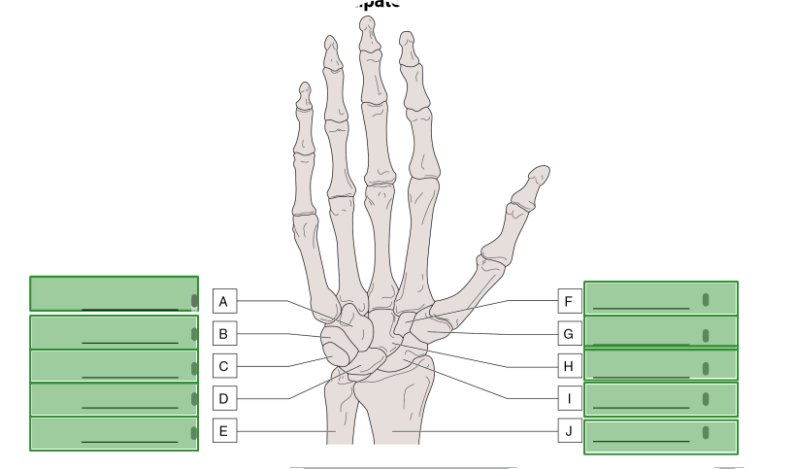

- Hamate → ______A____________
- Lunate → ________D__________
- Pisiform → ________C__________
- Triquetrum → _______B___________
- Ulna → _________E_________
- Trapezoid → _______F___________
- Trapezium → _______G___________
- Capitate → _______H___________
- Scaphoid (navicular) → ________I__________
- Radius → ________J__________
123: Upon palpation, pain is noted in the anatomical snuff box and the scaphoid-lunate articulation. To initially assess the range of motion, the athletic trainer has the athlete go through the ranges of motion actively. Please match the photograph to the hand, wrist, or forearm motions that are being pictured. (Please note that arrows pointing in both directions indicate the pair of motions.)
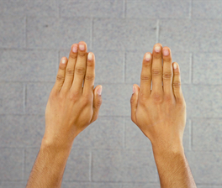
Drop Spot
a. Forearm supination and pronation
*b. Metacarpal phalangeal adduction
c. Interphalangeal flexion and extension
d. Thumb flexion and extension
e. Wrist flexion and extension

124. Upon palpation, pain is noted in the anatomical snuff box and the scaphoid-lunate articulation. To initially assess the range of motion, the athletic trainer has the athlete go through the ranges of motion actively. Please match the photograph to the hand, wrist, or forearm motions that are being pictured. (Please note that arrows pointing in both directions indicate the pair of motions.)
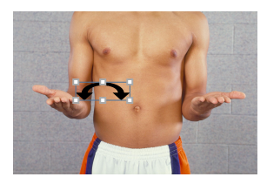
Drop Spot
*a. Forearm supination and pronation
b. Metacarpal phalangeal abduction
c. Interphalangeal flexion and extension
d. Thumb flexion and extension
e. Wrist flexion and extension

125. Upon palpation, pain is noted in the anatomical snuff box and the scaphoid-lunate articulation. To initially assess the range of motion, the athletic trainer has the athlete go through the ranges of motion actively. Please match the photograph to the hand, wrist, or forearm motions that are being pictured. (Please note that arrows pointing in both directions indicate the pair of motions.)
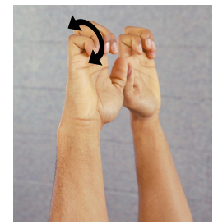
Drop Spot
a. Forearm supination and pronation
b. Interphalangeal abduction
*c. Metacarpal phalangeal flexion and extension
d. Thumb flexion and extension
e. Wrist flexion and extension

126. Upon palpation, pain is noted in the anatomical snuff box and the scaphoid-lunate articulation. To initially assess the range of motion, the athletic trainer has the athlete go through the ranges of motion actively. Please match the photograph to the hand, wrist, or forearm motions that are being pictured. (Please note that arrows pointing in both directions indicate the pair of motions.)
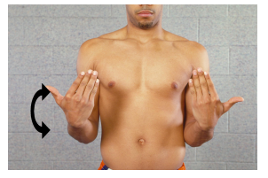
Drop Spot
a. Forearm supination and pronation
b. Metacarpal phalangeal abduction
c. Interphalangeal flexion and extension
d. Thumb flexion and extension
*e. Wrist flexion and extension

127. Upon palpation, pain is noted in the anatomical snuff box and the scaphoid-lunate articulation. To initially assess the range of motion, the athletic trainer has the athlete go through the ranges of motion actively. Please match the photograph to the hand, wrist, or forearm motions that are being pictured. (Please note that arrows pointing in both directions indicate the pair of motions.)
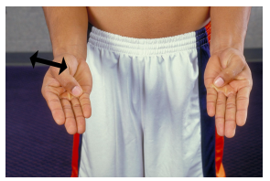
Drop Spot
a. Thumb abduction and adduction
b. Metacarpal phalangeal abduction
c. Interphalangeal flexion and extension
*d. Thumb flexion and extension
e. Opposition

128. Upon palpation, pain is noted in the anatomical snuff box and the scaphoid-lunate articulation. To initially assess the range of motion, the athletic trainer has the athlete go through the ranges of motion actively. Please match the photograph to the hand, wrist, or forearm motions that are being pictured. (Please note that arrows pointing in both directions indicate the pair of motions.)
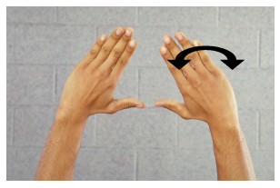
Drop Spot
a. Metacarpal phalangeal adduction
*b. Radial and ulnar deviations
c. Metacarpal phalangeal flexion and extension
d. Thumb abduction and adduction
e. Thumb opposition

129. Upon palpation, pain is noted in the anatomical snuff box and the scaphoid-lunate articulation. To initially assess the range of motion, the athletic trainer has the athlete go through the ranges of motion actively. Please match the photograph to the hand, wrist, or forearm motions that are being pictured. (Please note that arrows pointing in both directions indicate the pair of motions.)
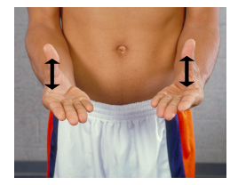
Drop Spot
a. Metacarpal phalangeal adduction
b. Thumb flexion and extension
c. Metacarpal phalangeal flexion and extension
*d. Thumb abduction and adduction
e. Thumb opposition

130. Upon palpation, pain is noted in the anatomical snuff box and the scaphoid-lunate articulation. To initially assess the range of motion, the athletic trainer has the athlete go through the ranges of motion actively. Please match the photograph to the hand, wrist, or forearm motions that are being pictured. (Please note that arrows pointing in both directions indicate the pair of motions.)
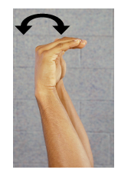
Drop Spot
a. Metacarpal phalangeal adduction
b. Radial and ulnar deviations
*c. Metacarpal phalangeal flexion and extension
d. Thumb abduction and adduction
e. Thumb opposition

131. Upon palpation, pain is noted in the anatomical snuff box and the scaphoid-lunate articulation. To initially assess the range of motion, the athletic trainer has the athlete go through the ranges of motion actively. Please match the photograph to the hand, wrist, or forearm motions that are being pictured. (Please note that arrows pointing in both directions indicate the pair of motions.)
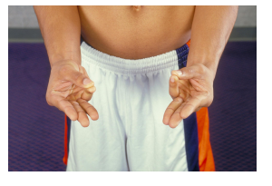
Drop Spot
a. Metacarpal phalangeal adduction
b. Thumb flexion and extension
c. Metacarpal phalangeal flexion and extension
d. Thumb abduction and adduction
*e. Thumb opposition

132. Upon palpation, pain is noted in the anatomical snuff box and the scaphoid-lunate articulation. To initially assess the range of motion, the athletic trainer has the athlete go through the ranges of motion actively. Please match the photograph to the hand, wrist, or forearm motions that are being pictured. (Please note that arrows pointing in both directions indicate the pair of motions.)
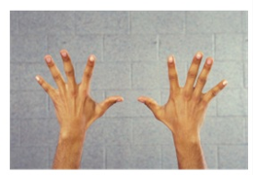
Drop Spot
*a. Metacarpal phalangeal abduction
b. Radial and ulnar deviations
c. Metacarpal phalangeal flexion and extension
d. Thumb abduction and adduction
e. Thumb opposition

Multiple Select Question
133. Upon palpation of the anatomical snuff box, there was pain and discomfort. Which muscle tendons form the anatomical snuff box? Choose all that apply.
*a. Extensor pollicis longus
b. Flexor pollicis brevis
c. Adductor pollicis brevis
*d. Abductor pollicis longus
e. Adductor pollicis longus
f. Abductor pollicis brevis
g. Flexor pollicis longus
*h. Extensor pollicis brevis

Drag and Drop Question
134. Read the introduction. The athletic trainer does manual muscle testing to assess this athlete’s strength. Move the muscle that is associated with each joint motion to the appropriate box.
Introduction: The active range of motion is painful for this athlete in wrist extension, radial deviation, and a combination of those motions. There is some pain with wrist flexion, but “nothing like it is when I bring my wrist back.”
The passive range of motion is painful in these same three movements (wrist extension, radial deviation, and wrist extension or radial deviation combined).
- Forearm supination: Drop spot 1
- Forearm pronation: Drop spot 2
- Wrist flexion: Drop spot 3
- Wrist extension: Drop spot 4

- Biceps brachii → Drop spot 1
- Pronator teres → Drop spot 2
- Supinator → Drop spot 1
- Pronator quadratus → Drop spot 2
- Flexor carpi radialis → Drop spot 3
- Flexor carpi ulnaris → Drop spot 3
- Extensor carpi ulnaris → Drop spot 4
- Extensor carpi radialis longus → Drop spot 4

135. Read the introduction. The athletic trainer does manual muscle testing to assess this athlete’s strength. Move the muscle that is associated with each joint motion to the appropriate box.
Introduction: The active range of motion is painful for this athlete in wrist extension, radial deviation, and a combination of those motions. There is some pain with wrist flexion, but “nothing like it is when I bring my wrist back.”
The passive range of motion is painful in these same three movements (wrist extension, radial deviation, and wrist extension or radial deviation combined).
- Radial deviation: Drop spot 1
- Ulnar deviation: Drop spot 2

- Biceps brachii
- Pronator teres
- Supinator
- Pronator quadratus
- Flexor carpi radialis → Drop spot 1
- Flexor carpi ulnaris → Drop spot 2
- Extensor carpi ulnaris → Drop spot 2
- Extensor carpi radialis longus → Drop spot 1
- Extensor carpi radialis brevis → Drop spot 1

136. Read the introduction. The athletic trainer does manual muscle testing to assess this athlete’s strength. Move the muscle that is associated with each joint motion to the appropriate box.
Introduction: The active range of motion is painful for this athlete in wrist extension, radial deviation, and a combination of those motions. There is some pain with wrist flexion, but “nothing like it is when I bring my wrist back.”
The passive range of motion is painful in these same three movements (wrist extension, radial deviation, and wrist extension or radial deviation combined).
- Metacarpal phalangeal flexion: Drop spot 1
- Metacarpal phalangeal extension: Drop spot 2

- Abductor digiti minimi (5th)
- Palmar interossei
- Profundus
- Lumbricales (2nd to 4th) → Drop spot 1
- Flexor digiti minimi (5th) → Drop spot 1
- Flexor digitorum superficialis
- Extensor indicis (2nd) → Drop spot 2
- Extensor digiti minimi (5th) → Drop spot 2
- Dorsal interossei (2nd to 4th)
- Extensor digitorum (2nd to 5th) → Drop spot 2

137. Read the introduction. The athletic trainer does manual muscle testing to assess this athlete’s strength. Move the muscle that is associated with each joint motion to the appropriate box.
Introduction: The active range of motion is painful for this athlete in wrist extension, radial deviation, and a combination of those motions. There is some pain with wrist flexion, but “nothing like it is when I bring my wrist back.”
The passive range of motion is painful in these same three movements (wrist extension, radial deviation, and wrist extension or radial deviation combined).
- Metacarpal phalangeal abduction: Drop spot 1
- Metacarpal phalangeal adduction: Drop spot 2
- Proximal interphalangeal flexion: Drop spot 3
- Distal interphalangeal flexion: Drop spot 4

- Abductor digiti minimi (5th) → Drop spot 1
- Dorsal interossei (2nd to 4th) → Drop spot 1
- Extensor digiti minimi (5th)
- Extensor digitorum (2nd to 5th)
- Extensor indicis (2nd)
- Flexor digiti minimi (5th)
- Profundus → Drop spot 4
- Flexor digitorum superficialis → Drop spot 3
- Lumbricales (2nd to 4th)
- Palmar interossei → Drop spot 2

138. Read the introduction. The athletic trainer does manual muscle testing to assess this athlete’s strength. Move the muscle that is associated with each joint motion to the appropriate box.
Introduction: The active range of motion is painful for this athlete in wrist extension, radial deviation, and a combination of those motions. There is some pain with wrist flexion, but “nothing like it is when I bring my wrist back.”
The passive range of motion is painful in these same three movements (wrist extension, radial deviation, and wrist extension or radial deviation combined).
- Interphalangeal extension (both DIP and PIP): Drop spot 1
- First metacarpophalangeal joint flexion: Drop spot 2
- First interphalangeal joint flexion: Drop spot 3

- Abductor pollicis longus and brevis
- Digiti minimi
- Extensor digiti minimi (5th) → Drop spot 1
- Extensor digitorum (2nd to 5th) → Drop spot 1
- Extensor pollicis longus → Drop spot 3
- Extensor indicis (2nd) → Drop spot 1
- Extensor pollicis brevis → Drop spot 2
- Opponens pollicis

139. Read the introduction. The athletic trainer does manual muscle testing to assess this athlete’s strength. Move the muscle that is associated with each joint motion to the appropriate box.
Introduction: The active range of motion is painful for this athlete in wrist extension, radial deviation, and a combination of those motions. There is some pain with wrist flexion, but “nothing like it is when I bring my wrist back.”
The passive range of motion is painful in these same three movements (wrist extension, radial deviation, and wrist extension or radial deviation combined).
- Thumb abduction: Drop spot 1
- Opposition: Drop spot 2

- Abductor pollicis longus and brevis → Drop spot 1
- Digiti minimi → Drop spot 2
- Extensor digiti minimi (5th)
- Extensor digitorum (2nd to 5th)
- Extensor pollicis longus
- Extensor indicis (2nd)
- Extensor pollicis brevis
- Opponens pollicis → Drop spot 2

Multiple Select Question
140. The athletic trainer decides that this injury may be bone related and decides the injury warrants an x-ray. Who can order the x-ray for this injury? Choose all that apply.
a. Athletic trainer
*b. Physician
c. Parents
d. Only a hand and wrist orthopedic specialist physician
*e. Physical therapist (in certain states)
*f. Radiologist

141. What is the athletic trainer’s differential diagnosis of this athlete’s injury? Which injuries or conditions are possible based on the examination? Choose all that apply.
a. Bennett’s fracture
b. Bishop’s deformity
c. Boutonniere deformity
*d. Scapho-lunate disarticulation
*e. Scaphoid fracture
f. Colles fracture
*g. De Quervain’s syndrome

Testlet 3
Please use the following information to answer the questions in this testlet.
A 19-year-old female field hockey player sees the athletic trainer early one morning in the athletic training facility. She complains of feeling really tired. She tells the athletic trainer that she feels like she cannot get enough sleep. Her additional history is as follows:
- She has a history of headaches, but denies having one today.
- She could not get warm yesterday, but today her head feels hot.
- She has a sore throat and still has her tonsils.
- She has seasonal allergies, an allergy to sulfa drugs, and shellfish.
- She takes Tylenol when she has a headache.
- She tried to eat a hamburger last night but vomited and does not feel like eating today.
- She took care of her boyfriend last week, and he had similar symptoms.
- She collided with another player last week and was sore for a day. Her abdomen is a little sore.

Drag and Drop Question
142. What question does the athletic trainer need to ask regarding a history for this injured athlete? What are the anatomical parts of the mouth and throat?
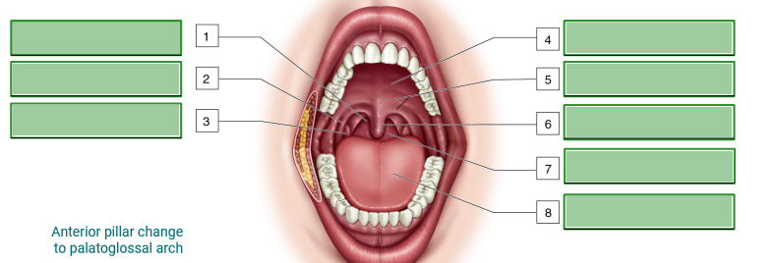
- Anterior pillar change to palatoglossal arch → _________2_________
- Hard palate → _______4___________
- Right tonsil → ________3__________
- Pharynx → _______7___________
- Soft palate → _________5_________
- Uvula → _________6_________
- Tongue → _______8___________
- Posterior pillar change to palatopharyngeal arch → ______1____________

Multiple Select Question
143. As the athletic trainer conducts the history portion of the examination, they are also incorporating several special tests. Which tests would be most appropriate for the athletic trainer’s patient based on the information gathered at this point? Choose all that apply.
*a. Auscultation of the abdomen
*b. Auscultation of the thoracic cavity
c. BESS or Rhomberg
d. Brudzinski’s test
e. Ophthalmoscope of the eyes
*f. Otoscope of ears, nose, and throat
*g. Palpation of the abdomen

Drag and Drop Question
144. Review the test findings and then drag the organs listed to their proper abdominal quadrant.
Test Findings: The special test performed revealed the following things:
- Auscultation of the abdomen and thoracic cavity is normal.
- Examination of the nose and ears is within normal limits.
- Examination of the throat reveals that it is red with white exudate, and the tonsils are swollen.
The athletic trainer does palpation.
Left Upper Quadrant | Right Upper Quadrant | Left Lower Quadrant | Right Lower Quadrant
Drop spot 1 | Drop spot 2 | Drop spot 3 | Drop spot 4

- Appendix → Drop spot 4
- Cecum → Drop spot 4
- Bladder (R) → Drop spot 4
- Bladder (L) → Drop spot 3
- Duodenum → Drop spot 2
- Gallbladder → Drop spot 2
- Left adrenal gland → Drop spot 1
- Left kidney → Drop spot 1
- Pancreas → Drop spot 1
- Sigmoid colon → Drop spot 3

145. The athletic trainer does palpation.
Left Upper Quadrant | Right Upper Quadrant | Left Lower Quadrant | Right Lower Quadrant
Drop spot 1 | Drop spot 2 | Drop spot 3 | Drop spot 4

- Left ovary → Drop spot 3
- Left spermatic cord → Drop spot 3
- Left ureter → Drop spot 3
- Liver → Drop spot 2
- Right adrenal gland → Drop spot 2
- Right ovary → Drop spot 4
- Right spermatic cord → Drop spot 4
- Right ureter → Drop spot 4
- Spleen → Drop spot 1
- Stomach → Drop spot 1

Multiple Select Question
146. The athletic trainer finds both right quadrants and the lower left quadrant to be pain-free and within normal limits. There is concern about the possibility of an enlargement of organ tissue in the upper left quadrant. What examinations or assessment should the athletic trainer do at this point? Choose all that apply.
*a. Oral temperature
b. Take the patient’s blood glucose level
*c. Percussion of the abdomen
*d. Take blood pressure
*e. Percussion of the thoracic cavity
*f. Palpate lymph nodes
*g. Pulse
h. Request a urine sample from the patient

Drag and Drop Question
147. The examination reveals the following information:
- The body temperature is 100.2 °F.
- There is a dullness over solid organs in the abdomen.
- Percussion of the thoracic cavity is normal.
- The pulse rate is 88 and respirations are 12 per minute.
- The patient’s blood pressure is slightly higher than normal
There is a specific order in which percussion, palpation, and auscultation are to be performed. What is the order for these three special tests as they pertain to an abdominal examination?
Place these three tests in the correct order.
*1. Auscultation
*2. Palpation
*3. Percussion

Multiple Select Question
148. What is the athletic trainer’s differential diagnosis of this athlete’s injury? What are those injuries or conditions that are a result of the examination? Choose all that apply.
a. Abdominal aortic aneurysm
b. Appendicitis
c. Celiac disease
d. Colorectal cancer
*e. Mononucleosis
*f. Peptic ulcer disease (PUD)
*g. Splenomegaly

Testlet 4
Please use the following information to answer the questions in this testlet.
It is preseason camp for a small college men’s soccer team. Right after lunch, two soccer players bring a third soccer player to the athletic training facility. The two friends tell the athletic trainer that there is something wrong with their teammate. They tell the athletic trainer that Joe (the injured player) was “talking nonsense during lunch” and “did not look or act right.” They voice their concern about Joe and state they want to have Joe examined by the athletic trainer.

Multiple Select Question
149. What questions does the athletic trainer need to ask regarding a history for this injured athlete? Choose all that apply.
*a. Can you tell me what happened?
*b. Have you ever hurt your head previously?
*c. Do you have pain anywhere on your head?
*d. Are you having any other symptoms I should be aware of?
e. Why did you continue to play after you hit your head?
*f. Are you taking any medications?

150. What additional questions does the athletic trainer need to ask regarding a history for this injured athlete? Choose all that apply.
*a. Did you lose consciousness or black out?
*b. Does your neck bother you at all?
*c. Do you have any numbness and tingling down your arms or legs?
*d. What type of pain are you experiencing? In other words, is it a sharp pain? A dull ache? A throbbing pain?
*e. On a scale of 1 to 10, how would you rate your pain?
*f. Does your pain come and go or is it fairly constant?

151. The question text is in the image below:
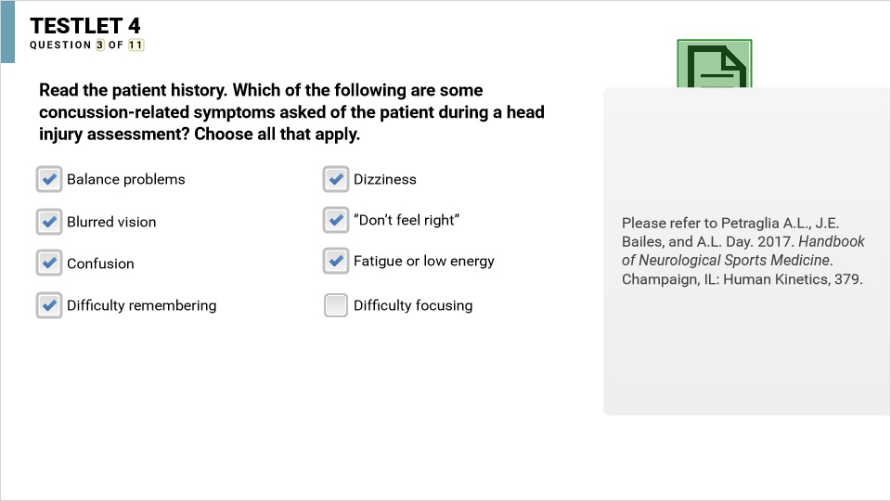
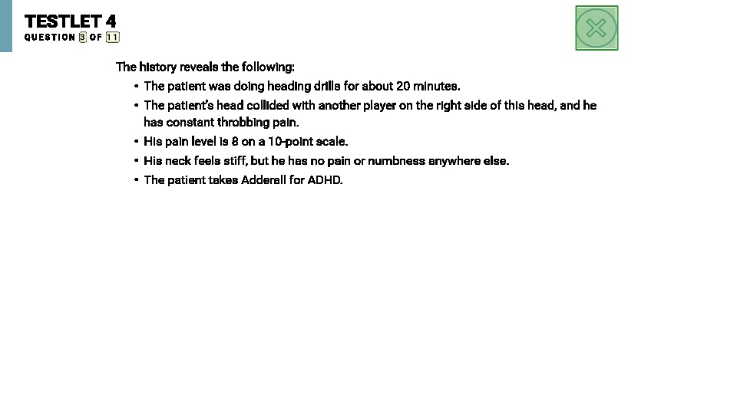
*a. Balance problems
*b. Dizziness
*c. Blurred vision
*d. Fatigue or low energy
*e. Confusion
f. Headache
*g. Difficulty in remembering
*h. Difficulty in focusing

Drag and Drop Question
152. Read the concussion evaluation. The athletic trainer inspects the head, face, and neck. Which of the following are the specific features the athletic trainer needs to inspect for when conducting an evaluation of head and face? Choose all that apply.
Concussion Evaluation:
The patient reveals the following information from the concussion evaluation:
- The patient has light sensitivity and a stiff and sore neck.
- He has a headache and is having difficulty in remembering things.

*a. Discoloration behind the eyes, known as “racoon eyes”
*b. Discoloration behind the ear at the mastoid process, known as a “Battle’s Sign”
c. Bleeding around the gumline of the teeth
d. Fluid coming from the eye, known as opthorrhea
*e. Fluid coming from ears, known as otorrhea
f. Deviation of the trachea
*g. Fluid coming from the nostrils, known as rhinorrhea
h. Discoloration around the neck and throat region

Matching Question
153. The athletic trainer performs an evaluation of the cranial nerves. Match the cranial nerve numbers with their name.
I | Drop spot 1
II | Drop spot 2
III | Drop spot 3
IV | Drop spot 4
V | Drop spot 5
VI | Drop spot 6
VII | Drop spot 7
VIII | Drop spot 8
IX | Drop spot 9
X | Drop spot 10
XI | Drop spot 11
XII | Drop spot 12

- Olfactory nerve → Drop spot 1
- Trochlear nerve → Drop spot 4
- Oculomotor nerve → Drop spot 3
- Optic nerve → Drop spot 2
- Abducens nerve → Drop spot 6
- Facial nerve → Drop spot 7
- Trigeminal nerve → Drop spot 5
- Vestibulocochlear nerve → Drop spot 8
- Glossopharyngeal nerve → Drop spot 9
- Vagus nerve →Drop spot 10
- Spinal accessory nerve → Drop spot 11
- Hypoglossal nerve → Drop spot 12

154. Match the cranial nerves with the testing method. Start by dragging the first six testing methods to the correct cells. One item is already completed for you.
I | Olfactory nerve | Drop spot 1
II | Optic nerve | Drop spot 2
III | Oculomotor nerve | Look up
IV | Trochlear nerve | Drop spot 3
V | Trigeminal nerve | Drop spot 4
VI | Abducens nerve | Drop spot 5

- Smell an alcohol wipe → Drop spot 1
- Check pupils with a light pen → Drop spot 2
- Clench teeth tightly together → Drop spot 4
- Look up → Drop spot 3
- Look side to side → Drop spot 5

155. Match the remaining six cranial nerves with the testing method.
I | Facial nerve | Drop spot 1
II | Glossopharyngeal nerve | Drop spot 2
III | Hypoglossal nerve | Drop spot 3
IV | Spinal accessory nerve | Drop spot 4
V | Vagus nerve | Drop spot 5
VI | Vestibulocochlear nerve | Drop spot 6

- Have the patient stick their tongue out, move tongue side to side, swallow → drop spot 6
- Have the patient smile, frown, wrinkle forehead → drop spot 1
- Have the patient taste something → drop spot 3
- Have the patient resist shoulder shrug → drop spot 5
- Conduct Romberg test → drop spot 2
- Have the patient say vowels (A, E, I, O, U) → drop spot 4

Multiple Choice Question
156. Read the patient’s report. What is the total Standardized Assessment of Concussion (SAC) score earned by this patient? Choose only one.
Patient Report:
From the previous questions, the athletic trainer discovers that the patient’s pupils are equal and react to light, and the Romberg test shows mild instability when progressing to eyes closed and single-leg position.
Next, the athletic trainer performs a standard assessment of concussion. The patient’s responses to each segment are below:
ORIENTATION
Month (August)
Date (The 26th)
Day of week (Wednesday)
Year (2026)
Time (within 1 hour) (Maybe 20 minutes until 2)
IMMEDIATE MEMORY [Note: (+) = a correct response; (―) = an incorrect response]

Word Trial 1 Trial 2 Trial 3
Elbow + + +
Apple + + +
Carpet — + —
Saddle + — +
Bubble — + —

CONCENTRATION (Note: BOLDED and Highlighted strings were correctly responded to by the patient, strings with a strikethrough were incorrectly responded to, and strings in normal font were not used for this patient.)

4-9-3 6-2-9
3-8-1-4 3-2-7-9
6-2-9-7-1 1-5-2-8-5
7-1-8-4-6-2 5-3-9-1-4-8
Months of the year, backward (Note: BOLDED and Highlighted strings were correctly responded to by the patient, strings with a strikethrough line were incorrectly responded to)
December - November - October - September - August -

July - June - May - April - March - February - January

Neurological assessment of cervical vertebrae dermatome, myotomes and reflexes are all within normal limits.
DELAYED RECALL
Elbow +
Apple +
Carpet +
Saddle +
Bubble —

a. 22/30
b. 23/30
*c. 21/30
- 20/30
- 24/30

Multiple Select Question
157. A balance error scoring system (BESS) is performed next. Which of the following are considered errors for the BESS? Choose all that apply.
Concussion evaluation:
The patient reveals the following information from the concussion evaluation:
- The patient has light sensitivity and a stiff and sore neck.
- He has a headache and is having difficulty in remembering things.

a. Rocking back and forth or side to side
*b. Lifting the hands off the iliac crests
*c. Lifting the forefoot or heel
*d. Stepping, stumbling, or falling out of the stance
*e. Flexing or abducting the hip more than 30°
*f. Opening the eyes
g. Moving the neck in any direction for more than 15°
*h. Remaining out of the stance for more than five seconds
i. Flexing the knee of the stance leg(s) more than 25°

158. Which of the following special tests might the athletic trainer use to further assess this patient’s dynamic balance, concentration, and coordination? Choose all that apply.
a. Stroop Word Color test
b. Trail Making test
*c. Serial sevens test
d. Hopkins Verbal Learning test
*e. Finger-to-nose coordination test
*f. Heel-to-toe tandem gait test

159. Read the scenario. What warnings should the athletic trainer share with this patient’s mother? Choose all that apply.
Scenario: As the athletic trainer was finishing this assessment, a woman walks in, and the patient recognizes her as his mother. The athletic trainer informs the mother that in all likelihood her son has suffered a concussion. The athletic trainer assures the mother there is nothing overly serious happening. However, the athletic trainer does want to give a list of potential red flags she needs to be on the lookout for during the next several hours.
*a. Any alteration in the level of consciousness
b. Excessive sleeping
*c. Fixed or abnormal pupil reactions, abnormal eye movements, or acute visual impairments
d. Senseless babbling or incoherent speech
*e. Any focal neurological symptoms occurring after head trauma
*f. Prolonged or recurrent generalized seizure
*g. Paralysis or progressive (either unilateral or bilateral) muscle weakness
*h. Bowel or bladder incontinence
*i. Acute severe headache, especially associated with nausea and vomiting or focal neurological deficits
j. Constant repeating of questions about self or past events

